EXPERIMENT- 2
Name: Shaik Sohail Subhani
Subject: Analog and Digital Communication
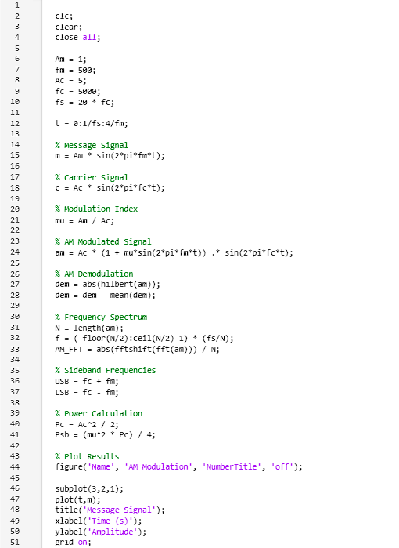
Fig. 1: MATLAB Code (Part 1)

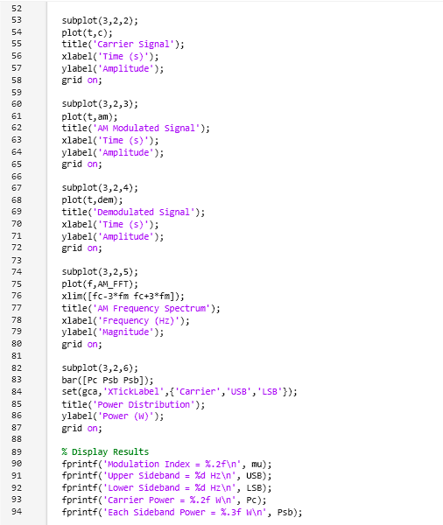
Fig. 2: MATLAB Code (Part 2)
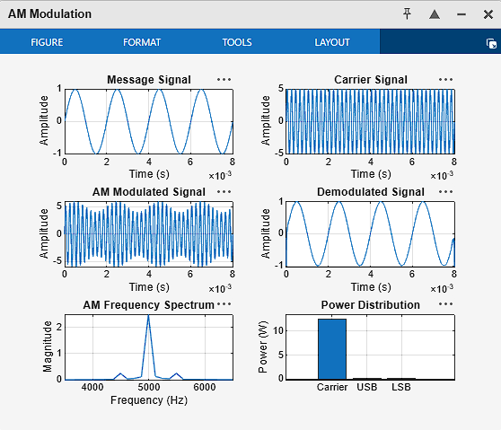
Fig. 3: Output – AM Modulation Figure Window

